**Answer the following questions with True or False. For each answer, give a rationale (i.e. If True state how, if False state why. No rationale earns you just half of the points if your True/False answer is correct, and zero point if your True/False answer is incorrect).**

1. What is the Internet and how is it related to the World Wide Web? What is the difference between Internet and WWW?

Internet is the global computer network that uses IP addresses to uniquely identify computers on the network. WWW is the collection of web sites around and pages around the world. WWW is a subdomain of internet and internet includes many other services such as email, online gaming…

1. Explain the difference between HTML block level elements and inline elements?

Block elements contain the whole width of the page by default and go from top to bottom. Block level elements can contain other block elements or inline elements.

Inline elements go from the left to right and they should be in inside block elements.

1. Name 3 Semantic web elements? Lecture1

Semantic element clearly tells its meaning to the browser and the developer - header, footer, nav

1. The following questions involve multiple choices; choose the correct option by putting a green highlight over, either Option A or Option B or Option C.

(2 points) For an HTTP Request received by a web server and processed without any error, the HTTP Response status code sent back to the browser is:

**Option A**. 404

**Option A**. 200

**Option A**. 500

1. What does HTTP error 403 mean?

403 error code in HTTP protocol means forbidden to access the page.

1. Why are we supposed to use <strong> instead of <b>?

<strong> is a proper semantics.

<b> apply bold style to text. could be achieved though CSS style.

1. Why shouldn’t you use table for layout?

Table has semantics and it should be used only to represent actual data not layout.

Other programmer may not understand pages properly. Also, table is not flexible.

1. Consider the HTML code fragment given below:

<a href=”http://www.mum.edu”><img src=”/mum-logo.png” alt=”MUM Logo” /></a>

* The URL referenced by the anchor (hyperlink) between elements is an example a relative referenced URL. **True** or False?
* The address assigned as the source(src) of the image elements is an example of a relative referenced url? True or False?

1. Write an example HTML code to display a hyperlink with an absolute URL.

<a href=”http://www.mum.edu”>Link</a>

1. Write an example HTML code to display a hyperlink with a relative URL.

<a href=”../index.html”>Home Page</a>

1. Write an example HTML code to display an image with a relative URL.

* <img src=” [images/mum-logo.png](http://www.mum.edu/mum-logo.png)” alt=”Logo”/>

1. Write an example HTML code to display an image with an absolute URL.

<img src=” <http://www.mum.edu/mum-logo.png>” alt=”Logo”/>

1. (2 point) What do we mean by Responsive Web Design? Give an example

Responsive web design means the making ta site that responds to the browser and devices width. Responsive design utilizes media queries to determine the available display area and new CSS techniques such as flexbox and grid to make design more flexible. For example, a web page displayed on computer and mobile devices differently. Mobile users can scroll websites vertically.

1. CSS properties settings of **visibility: hidden** versus **display: none**

**visibility hidden** will hide the element, but the element still takes spaces same as is visible

**display none** – will render page as though the element doesn’t exists

1. Explain what the clear property does?

Clear property makes the element under consideration clear of any floating elements, so that elements will not wrap around it.

1. Explain the difference between position absolute and position fixed?

Absolute: fixed position relative to the containing element. Containing element should be relative or absolute otherwise position is fixed relative to body.

Fixed: fixed position in relation to the browser.

1. What is the purpose of the <label> tag?

The purpose of label tag is to check the checkbox or radio buttons when selects label’s text.

Also, it can be used for layout purposes as well.

1. If the purpose of the form in the next exercise is to specify how many dog or cat pictures a person would like to see, would it be best to make the method it be GET or POST?

It would be ok to use GET since the query contains only type of animal and amount. (URL is short and data is not sensitive)

1. HTML Form submission when form's method attribute is get versus post – Lecture4
2. In JavaScript, when a function is defined inside another function, the outer scope has access to the inner function’s variable? True or False

JavaScript scope chaining works from its current scope to the outer scope until the global scope. That is why outer function doesn’t have access to its inner functions variable.

1. By using the jQuery selector, $<”div”>, sec can select the all div tags present on the our webpage? **True** or False?
2. In JavaScript, when a variable is declared, (e,g – var dateOfBirth;) and no value is assigned to it, the default value it gets is null? True or **False**;

Variable default value it undefined when variable is declared and no value is assigned to this variable.

**Give short answers (and examples where required) to the following questions:**

1. Does JavaScript support function overloading? Explain your answer by giving an example using code.

*Answer: Overloading is not supported in the JS. For example, on the code below.*

*function log(aaa) {*

*console.log(aaa);*

*}*

*function log(aaa, bbb) {*

*console.log(aaa, bbb);*

*}*

*Last declaration log function always work when we call log function with any number of parameter.*

1. Explain the difference between Obtrusive versus Unobtrusive JavaScript. Give an example of each, to illustrate your answer.

*Obtrusive event handler is that attaches event to element in the HTML.*

*Unobtrusive is attaches event to element in the JS.*

*function testAlert(){*

*alert(“test”);*

*}*

Obtrusive: <button onclick=”*testAlert*();”>Test Alert</button> in HTML

Unobtrusive: <button id=”btn”>Say Hi</button> in HTML

const testAlert = document.getElementById(“btn”);

testAlert.onclick = *testAlert*;

1. In terms of JS programming
   1. What is a Closure? Give an example in the code

Closure is a first-class function that binds to free variables that are defined in its execuion environment.

const x = 1;

function f() {

let y = 2;

const sum = function() {

const z = 3;

console.log(x + y + z);

}

y = 10;

return sum;

}

const g = f();

g();

* 1. What is the free variable?

A variable referred to by function that is not one of its parameters or local variables.

* 1. What is an IFFE? Give an example in code.

IFFE means Immediately Invoked Function Expression. It declares function and immediatlly calls an anonymous function.

var funcs = [];

for (var i = 0; i < 5; i++) {

funcs[i] = (function(n){

return function() {return n;}

}(i));

};

* 1. What is the Revealing Module Pattern? Give an example in code?

Module Pattern uses IIFE for the purpose that encapsulate methods and properties

var counter = (function() {

var privateCounter = 0;//private property

function changeBy(val) { //private method  
 privateCounter +=val;

}

return {

increment: function() {changeBy(1);},

decrement: function() {changeBy(-1);},

value: function() {return privateCounter;}

}

})();

1. In Web Application programming, what do we mean by **AJAX** (You may give an example to illustrate your answer)?

*AJAX means Asynchronous JavaScript and XML. With AJAX, web application can send and retrieve data from a server asynchronously which means in the background.*

1. With reference to Inheritance in JavaScript, what is the difference and the relationship between the “.__proto__” property and the .prototype property? (You may give an example to illustrate your answer).

*__proto__ is the actual object that is used in the lookup chain to resolve methods, etc. prototype is the object that is used to build __proto__ when you create an object with new*

*( new foo ).__proto__ === foo.prototype;*

*( new foo ).prototype === undefined;*

1. With regards to JavaScript’s support for Functional programming, what is a First-class function? Give an example.

*First class function means when function in that language treated like any other variable. For example,*

*Functions can be assigned to variables,*

*const myfunc = function(a, b) {return a * b};*

*Functions can passed as parameter to other functions*

*function apply(a, b, myfunc) {*

*const y = myfunc(a,b);*

*return y;*

*}*

*Functions can be returned by another functione.*

*function getAlert(str) {retun function() {alert(str);}}*

1. Write a code example of a Function declaration

*function declare() { return ”Oogii”; }*

1. Write a code example of a Function Expression

*const expression = function { return ”Oogii”; }*

1. Write a code example of an Anonymous Function

*function a() { return function { return ”Oogii”; }}*

1. Write a code example of an Arrow Function

*const sum = (a,b) => { return a + b; }*

1. In JavaScript programming, what is referred to as, "Hoisting"? Give an example.

*Hoisting is JS engine reserve special memory for functions(as whole) and variable names. Variables initially set to undefined.*

1. With reference to the JavaScript language, what is a Lexical Environment? Execution Context?

*The lexical environment is where your JS codes sitting physically. Every lexical environment has own execution context which that code running.*

1. With reference to JavaScript language versions, ES6 and above, how many possible Scopes are there?

* *Global*
* *Block /which used by let and const/*

1. Assume that a JavaScript source code file named, app.js, is added to a web page file named, index.html, using the <script> tag. If the first and only line of code is app.js is: console.log(this);

When the index.html page is opened in a web browser, what object will be printed to the console?

*It will log window to console when index.html page is opened.*

1. In client-side Web Application programming, what is referred to as "Event Bubbling"? Give an example.

*Event bubbling means the event captured and handled by the innermost element to the outer elements.*

*<div>*

*<p>text</p>*

*</div>*

*If we set onclick event on each element and click on element It will execute p element’s onclick event and then div’s onclick event.*

1. How do we prevent a click event on a hyperlink element from performing its default behavior of navigating to the url referenced by its href attribute?

**<a href=**[**http://www.test.com**](http://www.test.com) **onclick=”event.preventDefault();” >Anchor tag </a>**

1. The JavaScript Function object has 3 important/essential methods, namely. Briefly explain the purpose of each of these methods, by giving small code examples to support your answer.

* function.prototype.call(...)
* function.prototype.apply(...)
* function.prototype.bind(...)

bind-> creates a new function from an existing one by fixing the values of one or more parameters

call-> calls function immediately with given arguments provided as individually

apply-> calls function immediately with given arguments provided as an array

var me = {

     first: 'Otgonbayar',

    last: 'Mijiddorj',

     getFullName: function() { return this.first + ' ' + this.last; }

};

var log = function(height, weight) {

     console.log(`${this.getFullName()} ${height}  ${weight}`);

};

log.call(me, '175cm', '75kg'); // using call with individual args

log.apply(me, ['175cm', '75kg']);   // using apply with array argument

var logMe = log.bind(me);

logMe('175cm');

var logMeWeight = log.bind(me, '175cm');

logMeWeight('75kg');

1. Assume you want to use the Location API in your web application. What is the name of the object.property to use to check if the user's browser has support for this API?

navigator.geolocation.getCurrentPosition()

**JavaScript OOP:**

1. Create a new webapp. Include an index.html page and load a JavaScript file named, app.js. In app.js, **define a Javascript object** **literal** named, person with the following specification: - See Lab9

person data fields (properties):

- name (default value: "")

- dob (default value: today's date)

- age (default value: 0)

person methods:

- getName : should return the name value of the person object

- setName : should assign name with value of an input param, named, newName.

1. Next, create an object named, John, who IS-A person, with the following data:

name is John,

dob is 1998-11-09

age is 21

Next, print to the console, John's information as follows:

"John born on 1998-11-9 is 21 years"

1. Given that an employee IS-A person. Create an object named, employee. Define the following new properties for employee object:

- salary: 0.0

- hireDate: today's date

Then, add a new method to the employee object named, doJob, which takes a param named, jobTitle. And when doJob is called, the following info is printed to the console:

"Anna is a Programmer who earns $100000 in salary"

(See solution in Sakai++, under JavaScript-OOP-Inheritance)

/* eslint-disable require-jsdoc */

"use strict";

/**

* app.js

*/

const person = {

name: "",

dob: "",

age: -Infinity,

getName: function() {

return this.name;

},

setName: function(newName) {

this.name = newName;

}

};

const john = Object.create(person);

john.setName("John");

john.dob = new Date(1998,12,10);

john.age = 20;

console.log(`Name is ${john.getName()}`);

console.log(`${john.getName(0)}'s age is ${john.age}`);

const employee = Object.create(person);

employee.salary = 0.00;

employee.hireDate = new Date();

employee.doJob = function(jobTitle) {

console.log(`${this.name} is a ${jobTitle} who earns $${this.salary}`);

};

const anna = Object.create(employee);

anna.setName("Anna");

anna.dob = new Date(2000,11,9);

anna.age = 18;

anna.salary = 125000.00;

anna.hireDate = new Date(2019,3,17);

anna.doJob("Programmer");

1. Write a JavaScript function named, findOdds, that takes an array of numbers, as input, and returns an array containing only the odd numbers that are present in the input array. E.g. findOdds(1,2,3) should return [1,3], findOdds(1,2,3,4,5) should return [1,3,5] and so on.

function findOdds(...array) {

let a = [];

for(let i=0; i<array.length;i++) {

if(array[i]%2===0) a.push(array[i]);

}

return a;

}

1. Write code for an object named, Account, as a JavaScript object literal, with the following specifications:

Account properties:

- accountNumber (set the default value to an empty string)

- accountType (set the default value to an empty string)

- balance (set the default value to 0.0)

- status (set the default value to an empty string)

Account methods: Include the following methods:

- create (This method takes as input, data for accountNumber, accountType, balance and status, which it then assigns/sets to the respective Account object properties; and then it simply prints the message, "New Account, AC-0001, created successfully", where AC-0001 is the accountNumber passed to the method)

- toString (Returns a string representation of the Account object, in JSON format)

1. By applying the **Revealing Module Pattern**, re-implement code for the Account object described in Q6 above. Implement your code such that the accountNumber, accountType, balance and status properties are encapsulated as **private data fields**. Then add the following public getter/setter methods for some of the properties:

getAccountNumber - Returns the value of the accountNumber property,

getAccountType - Returns the value of the accountType property,

getBalance - Returns the value of the balance property,

getAccountStatus - Returns the value of the accountStatus property,

setAccountStatus - Takes as input parameter, accountStatus, which it assigns to the accountStatus property.

Also make the *create* and *toString* methods, public.

1. An object named, tomsCheckingAccount, IS-An Account. Applying JavaScript inheritance, write code that creates this object (tomsCheckingAccount), using the Object.create(...) method; and assigns to it the following values:

**tomsCheckingAccount property values**:

accountNumber - AC-0099",

accountType - "Checking",

balance - $16,595.99,

status - "Open"

Then, add a new method named, payFees, to this tomsCheckingAccount object, which takes as input, as fee amount and deducts it from the account's balance.

1. Using the Constructor function way, write code for an object named, Account, based on the specification given in Q6 above.
2. Using HTML, CSS and JavaScript, implement a mini-BankingApp as a single-page web application, as shown in the UI screenshot below, with the following features and functionalities.
3. Write an HTML page that contains the minimum elements to validate as HTML5, but other than that does not have any contents.

<!doctype html>

<html lang="en">

<head>

<meta charset="UTF-8">

<title>Page title</title>

</head>

<body>

</body>

</html>

1. (5 points) The screenshot/figure displayed below is of a basic Web (HTML) page, which is displaying a heading element (h1), with the text, **Hello Web Application Programming (WAP)!!!**

Write-down the basic HTML5 markup code for a complete web page that displays, as shown.

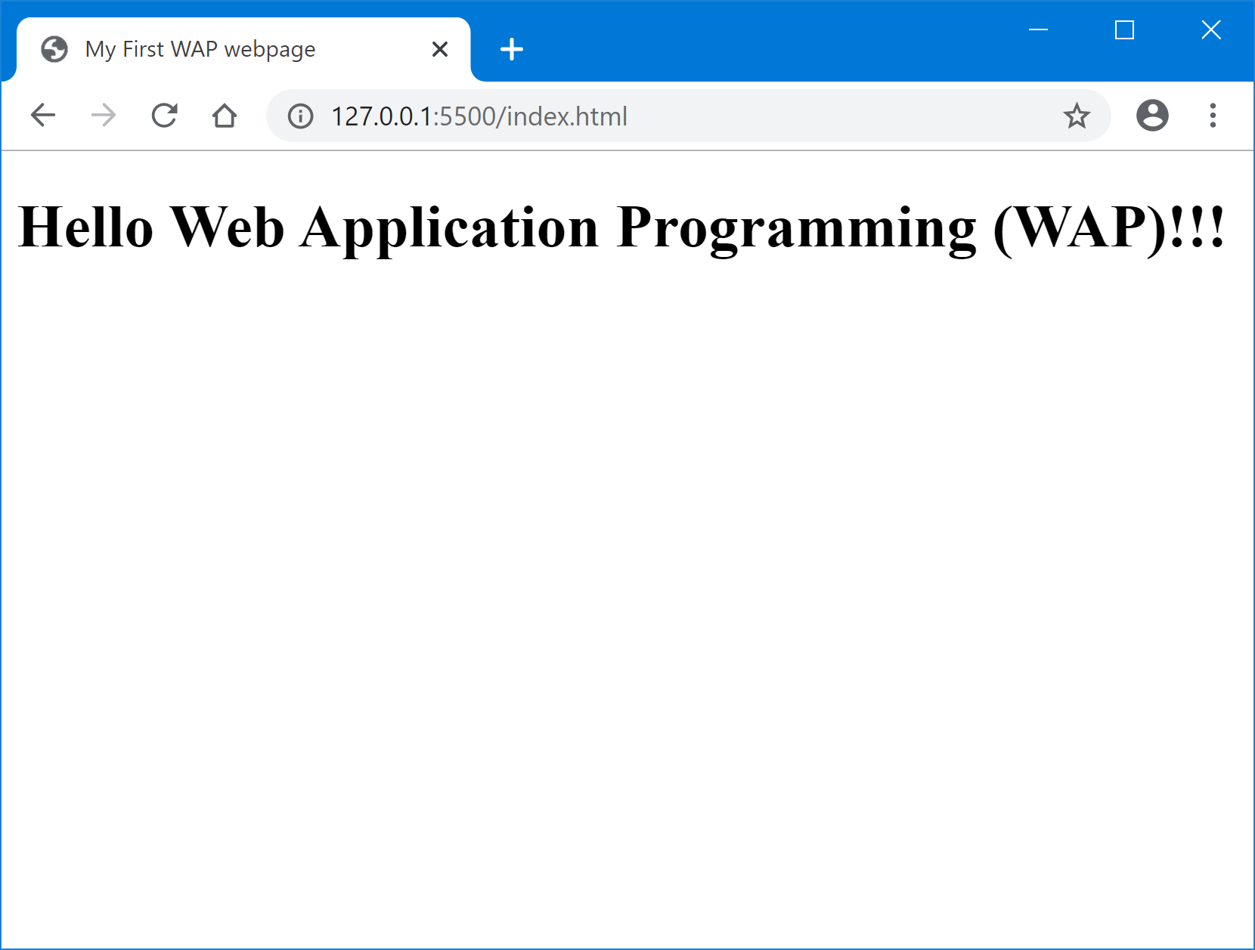

<!doctype html>

<html lang="en">

<head>

<meta charset="UTF-8">

<title>My First WAP webpage</title>

</head>

<body>

<h1>Hello Web Application Programming (WAP)!!!</h1>

</body>

</html>

1. (4 points) Given an image file named, mum-logo.png, write HTML code markup fragment to create a hyperlink with this image, such that when it is clicked on the browser, it takes the user to the homepage of our Maharishi University of Management’s website (i.e. [www.mum.edu](http://www.mum.edu)).
2. The following is considered bad, write some good HTML & CSS that gives the same result.

<p> This a paragraph</p><br/><br/><br/>

<p> This is another paragraph</p>

Answer:

<!doctype html>

<html lang="en">

<head>

<meta charset="UTF-8">

<title>Page title</title>

</head>

<body>

<p id=”first”> This a paragraph</p>

<p> This is another paragraph</p>

</body>

</html>

CSS

#first { paddging-bottom: 3em}

1. What is the foreground or background color?

|  |  |
| --- | --- |
| <body>  <div id=”first”> First  <ul>  <li class=”this that”>  <strong>Some</strong> Text  </li>  <li class=”such”> Then  <em id=”so”>Ither</em>  </li>  </div>  </body> | body {background-color: ivory;}  #first {color: orange;}  #such {color: yellow;}  #so, .that {background-color: lightblue;}  ul, .that {background-color: white;}  .this.that {color:red;}  .that strong {background-color: pink;}  .such > em {color: coral;}  div {color:green;} |

|  |  |  |
| --- | --- | --- |
|  | Foreground | Background |
| First | orange | ivory |
| Some | red | pink |
| Text | red | white |
| Then | orange | white |
| Other | coral | lightblue |

1. Explain the difference between the following selector
2. div, p{…} selects to elements of both div and p
3. div p{…} selects elements all p which are inside div
4. div > p {…} selects direct descendant p element of div
5. Based on the HTML in question 30: What is the height (in pixels) between top of the top border of the first <li> and top of the top border of the second <li>. Given the CSS:

li {

border: 3px;

padding: 7 px;

margin-top: 5 px;

margin-bottom: 5 px;

height: 30px;

}

height = 3 + 7 + 30 + 7 + 3 + max(10,5) =60 px.

Borders, only paddings of first li, element height and long margin of 2 li.

1. Draw a diagram showing the height, padding border and margin of the 2 li.
2. (4 points) Implement code for a web (html) page that displays the data for the CS472-WAP Class Attendance Register, as shown below:

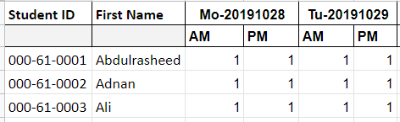

1. Write the HTML code required to display the following content in a web page:

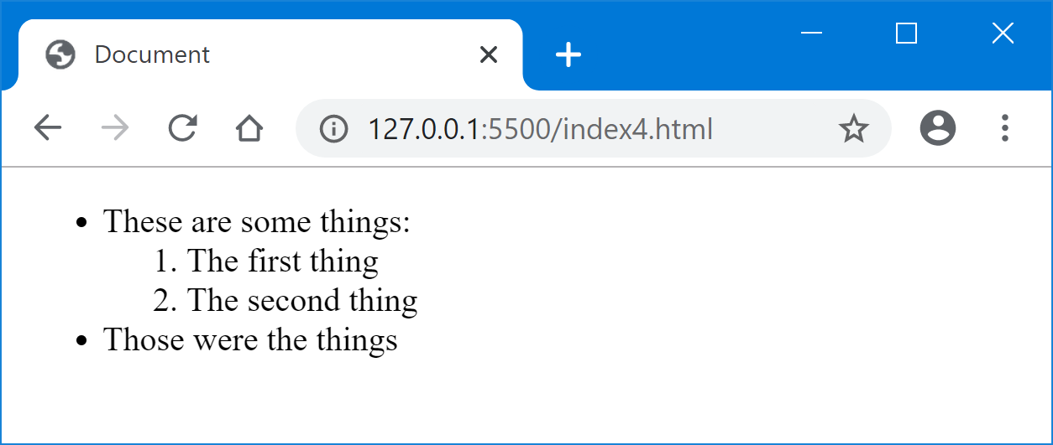

1. Implement code to display the following Web page layout:

